Chapter 2

RELATED LITERATURE AND STUDIES

This study sought to present related literatures from journals, websites and books and studies such as theses, and dissertations that have been previously conducted by other researchers. They are all organized and presented in a manner that gives more understanding about the importance of the research proposal. It also illustrates the theoretical and conceptual framework of the study.

Foreign Literature
In an article entitled Student Information System (2009), Raje stated that by using the online school management software, many teachers and school administrators have been able to effectively reduce time for carrying out the normal routine processes like cross-checking the examination papers, taking daily attendance and so on. As a result, the faculty can devote more time toward teaching and quality of lessons delivered has also improved a great deal.
According to Spencer et. al., in the book Micro Computer in Business (2005), putting large volume of data in a filing cabinet is not a particularly efficient way of handling dat. Because going all through these records every time you need to prepare a report is not efficient either. Instead you can use a computer and a database to manage the data efficient.
In 2005, Stairs stated in his review entitled “Information System for Today’s Business” that database as an organized collection of facts and information can contain information on customers, employees, inventory, competitors, sales information and much more. Most managers and executives believe a database is one of the most valuable and important parts of information system.

Local Literature
According to Paperless Trail Inc. (2010) in their article Record and Document Keeping for Companies in The Philippines, “Record Management ensures that any and all information and documents of a company is up to date and accurate”. Record management is the process of planning, controlling, directing, organizing, training, promoting, and other activities involved with respect to records creation, maintenance, use, and disposition in order to achieve adequate and proper documentation.
Lester Lee in his article entitled Uses and Importance of Computers (2009), Computer can process the given data very fast that a human being cannot. Computer can store huge amount of data. Computer can make decisions very quickly on given problems by using internal instructions. By connecting computer with each other we can form networks and this technique helped to invent internet which is a source of information almost for every kind of computer user.
The Bureau of Records Management, in their handbook entitled The Creation of Record (2005), stated that record management focuses more on the finding aspect for purpose of practicality and convenience. Since records are being retained or filed for future possible use and purposes, the so called finding aspect is therefore essential in document management. The safekeeping of records is an essential function of record officers but being able to find them immediately, when wanted is more important. A needed data when lost or misplaced can delay the work of several personnel and may result to loss in labor hours.
In an article entitled Automation of Grading System (2009), Fr. Jerome Marquez stated that the plan to automate the 2010 national election reverberates clearer to school faculty and staff as SJCS begins to automate its grading system starting this school year 2009-2010. The shift to automate the grading system, hopefully, will increase efficiency of school staff and allow teachers to focus more on teaching than clerical recording.

Foreign Studies
According to Rod Lauren et. al., in their study Manual Computer Processing (2005), the performance of the computer in a complex solution procedure to program and the electronic speed of compilation mean that the problem would not be solved because of time, request by the manual computation can be manipulated.
In the study Interdisciplinary Research on EDP (2007) by Bethany Warwick et. al., compared electronic data processing to other methods. Concrete and accurate information is very crucial, which is mostly compromised in manual or traditional method. That is why electronic data processing system are becoming more and more sufficient that other methods. They stated that an electronic data processing system becomes more efficient and economical. The major limitation of manual data processing includes its inability to handle large volumes of work and its reliance on many cumbersome and tedious methods. It is also more susceptible to error and slower than any data processing methods because it requires human efforts in most data processing activities. Therefore, electronic data processing system are used by all organizations with complex data processing requirements.

Local Studies
According to Joseph Azusera on his Stock Movement System (2005), manual system in retrieving, maintaining, securing and filing of records consume time and effort. There are some cases wherein misplaced records are taking place because the years gone by. Furthermore, these files were only kept in envelopes, folders, or in wooden racks. There are also instances when the information is given to a wrong person, which may affect quality of service.
In a study of AMA Computer College Tarlac Students (Parazo et. al., 2010) entitled “Campus Information System for Ecumenical Christian College”, “An information system is a collection of hardware, software, data, people and procedures that are designed to generate information, which supports the day, short-range and long-range activities of users in an organization.” The study compares to the proposed study in terms of information management principles. They somehow differ in the scope which only focuses on the grade computation and ranking records.

According to an unpublished study of Canta et. al. (2010), entitled “Automated Grading System”, the grade of a student is a scale which determines students who need more improvement and require more assistance which will help teachers in guiding them towards their development. It also shows where students excel most so they can be honed and encouraged to continue their good work, improve more, and aim higher. At the end, it will be the reference for the judgment of whether a student can step up to a higher level of learning or remain to be polished. From these reasons, it is clearly concluded how important it is to make sure that the grades of the students are accurately calculated and safely stored in a well-founded database.

Theoretical Framework
The theoretical framework demonstrates how the existing and the proposed system work. With illustrations and processes, it also shows how the existing system progress into the proposed system.
Shown in Figure 2.0 is the input-process-output paradigm of the existing and to the proposed system. Through this, it helps visually elaborate the progress undergone by a user input that is processed to produce an output based from the given input.

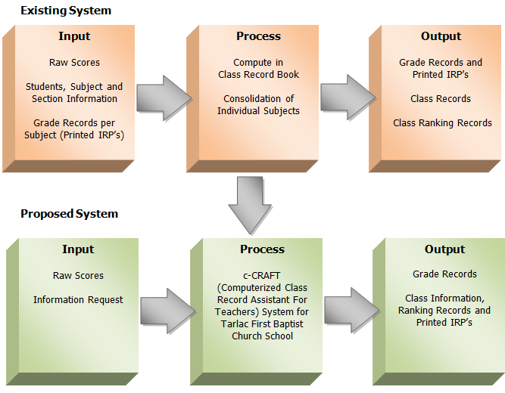

Figure 1.0 Theoretical Framework of the Study

Figure 2.0 Theoretical Framework of the Study

In the existing system, raw scores, specific information such as student, subject and section and grade records per subject through printed IRP’s serve as the user’s input. From these inputs, the class record books are scanned to come up with information, result or output. Such results are then organized records like grades and ranking or printed IRP’s.
The proposed system, conversely, give a simple user input, efficient processing of data input and produces reliable and accurate output. The system inputs include raw scores from student performance activities like quizzes, assignments, examinations, etc. and information request by specifying the teacher, subject and section. These inputs are then processed that will ultimately produce outputs in the form of grade and class records, class ranking and printed IRP’s.

Conceptual Framework

The conceptual framework simply exhibits the design and perception of the systems processes and elements. As shown in Figure 2.1, one component of the system are the users which are mainly three entities; subject teacher, class adviser and principal. These three entities are the only users that can use the system. All of the users are configured to viewing privileges according to their position.
Accounts of subject teachers are limited only in manipulating data over the subjects appointed to them by the principal. Editing and adding input (raw scores), viewing and printing the teacher’s respective subjects are the only privileges of the subject teacher. The class adviser have the same privileges of the subject teachers, however, they have the ability to view IRP’s per subject of the teacher’s advisory section as well as the viewing and printing of class ranking and editing the final rating which features the extra-curricular standings of the students. The principal has the privilege of creating, deleting and editing accounts and students information but excludes the right to manipulate student grades in the form of IRP’s and ranking given only the opportunity to view them.
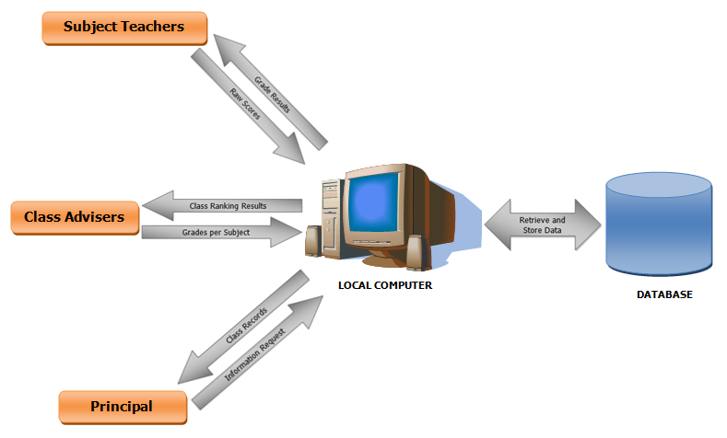

Figure 2.1 Conceptual Framework of the Study

